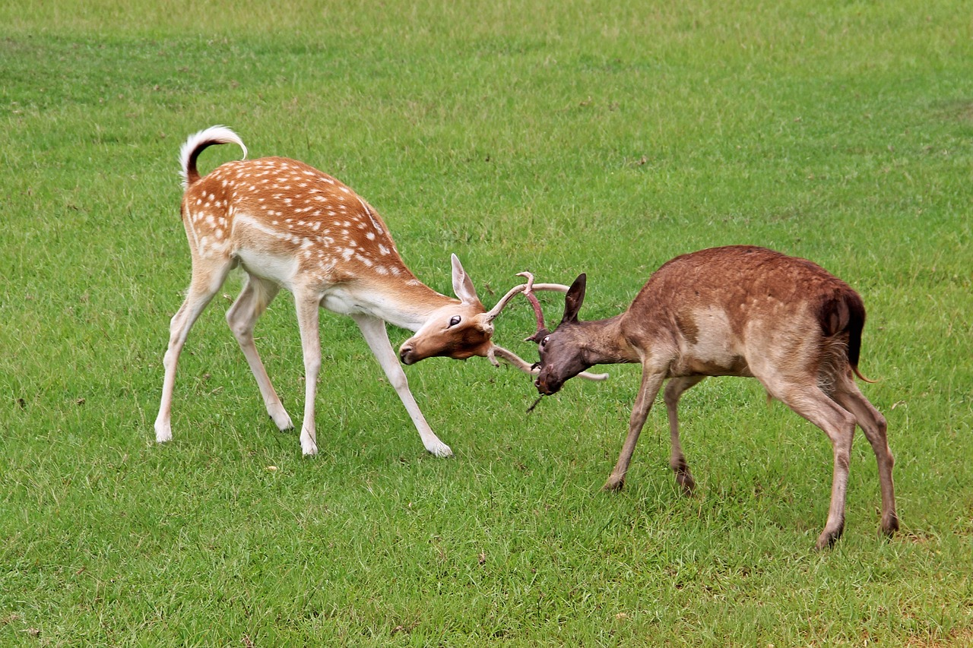

5-Animal Qigong
Module 2 Homeplay
Take on the Energy of the Deer to Diminish Anxiety Deepening Practices

Deepening Practices
Each day this week, make time to practice the Tiger Form followed by the Deer Form, using the recording as your guide until you no longer need it. Daily practice will build your muscle memory and keep it fresh in your mind as you “play” with the first 2 of the animal frolics.
If you have a chance to warm up with the hand forms and stances, that would be ideal as this maintains manual dexterity and strengthens legs and hips for long-term health. Practice with a sense of play to release tension and stress, knowing that 59 generations before you have practiced this Qigong for their health and vitality!
Enjoy learning the Tiger and Deer forms!

