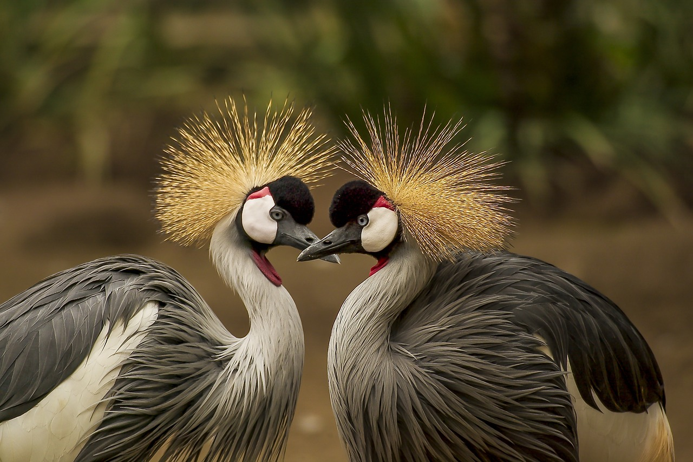
5-Animal Qigong
Module 5 Homeplay
Fly above life’s stress with the Crane!
Deepening Practices

We learn best through practice.
Practice the Crane form, modifying for any personal health projects. For example; if you have instability in one or both legs, do the upper body movements seated when you need to. Notice if any stuck emotions of grief come up to be released, and if they should arise, allow them to flow out of the body, using the practice to support the release.
If you need extra support, stimulate the Lung 2 points below the clavicle using the index and middle fingers, then place warmed palms over the same points, as if to give yourself a hug and melt away the “hard metal of sadness” so that your wings - and your heart - can beat again with strength and resilience.
Practice this elegant movement as often as you wish to support any lung health projects or sadness/grief that may be stuck in the body.

